**Manage Security and Compliance using WhiteSource Bolt**

WhiteSource Bolt for Azure DevOps is a FREE extension, which scans all your projects and detects open source components, their license and known vulnerabilities. Not to mention, we also provide fixes.

We've got you covered with over 200 programming languages support and continuous tracking of multiple open source vulnerabilities databases like the NVD, security advisories, peer-reviewed vulnerability databases, and popular open source projects issue trackers.

**WhiteSource Secures & Manages Your Open Source Usage**

WhiteSource integrates with your Azure DevOps or Team Foundation Server (TFS) continuous integration servers and detects all open source components in your software, without ever scanning your code. It provides you with real-time alerts on vulnerable and outdated open source components and generates comprehensive up-to-date inventory, licenses and security reports with only one click. You can scan any project up to 5 times a day.

**Get Real-Time Alerts on Security Vulnerabilities**

WhiteSource provides real-time feedback whenever a vulnerable open source component is added to your build or when a vulnerability is discovered in a component already used in your software. You will also be alerted on copyleft open source licenses and outdated libraries with suggested resolution paths.

**Note: For this demo, we are using Azure DevOps Demo Generator sample.**

[https://azuredevopsdemogenerator.azurewebsites.net](https://azuredevopsdemogenerator.azurewebsites.net/)

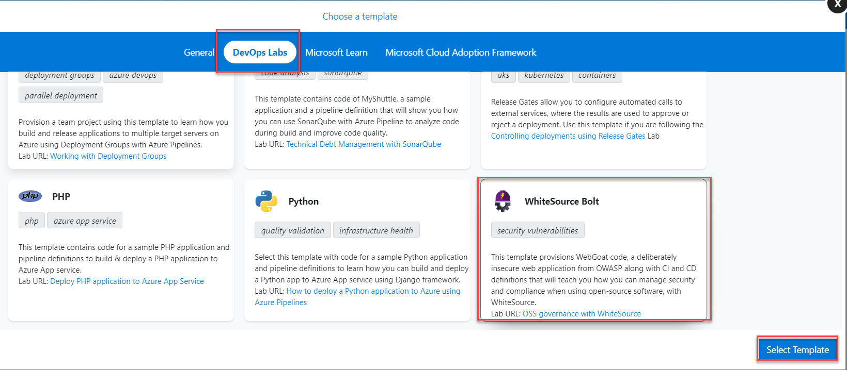

Step 1: Create WhiteSource Bolt Sample Project.

Select Organization: Choose from list

New Project Name: MyDemoProject

Selected Template: WhiteSource Bolt

One extension is not installed in Azure DevOps Organization so first install that.

Click on WhiteSource Bolt.

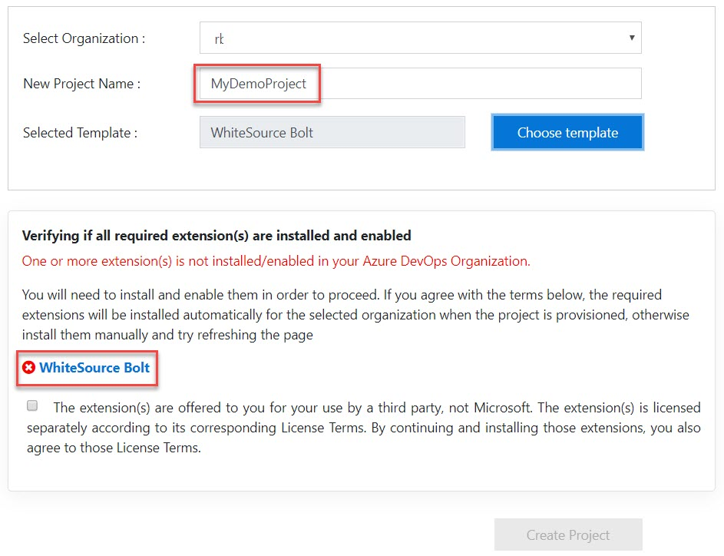

Step 2: Another browser tab will open and click on Get it free button.

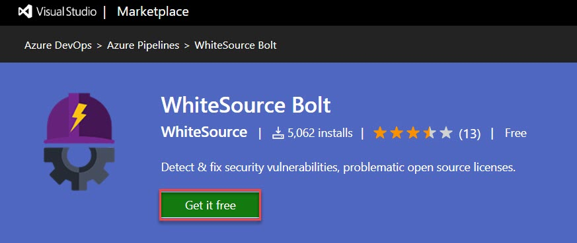

Step 3: Choose Azure DevOps Organization and click on Install button.

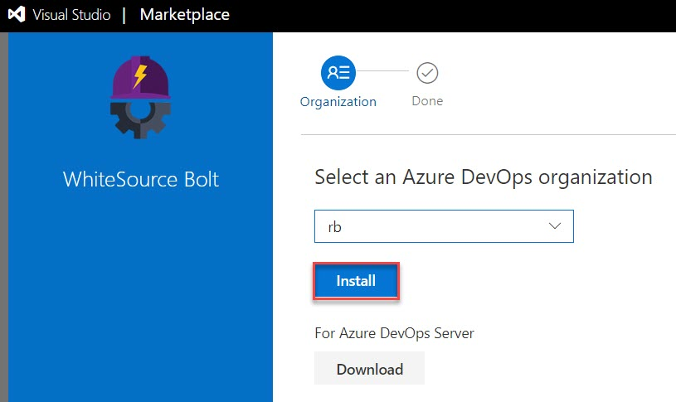

Step 4: Click on Proceed to Organization

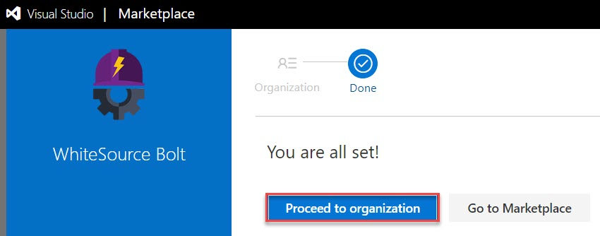

Step 5: Come back to WhiteSource Bolt Project page and refresh it. Now Extension is enabled. Click on Create Project.

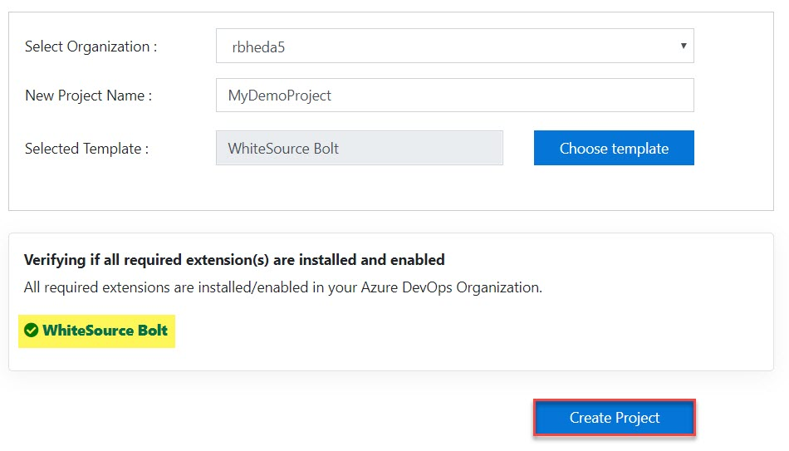

Step 6: Click on Navigate to Project button.

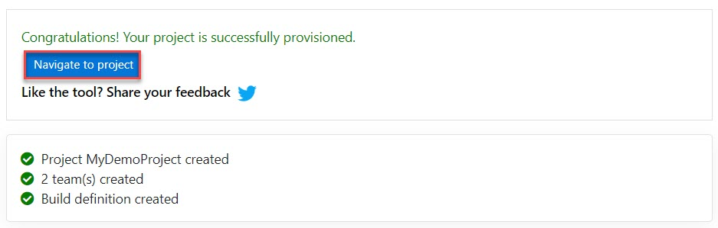

Step 7: Azure DevOps project, WhiteSource Bolt option available under Pipelines.

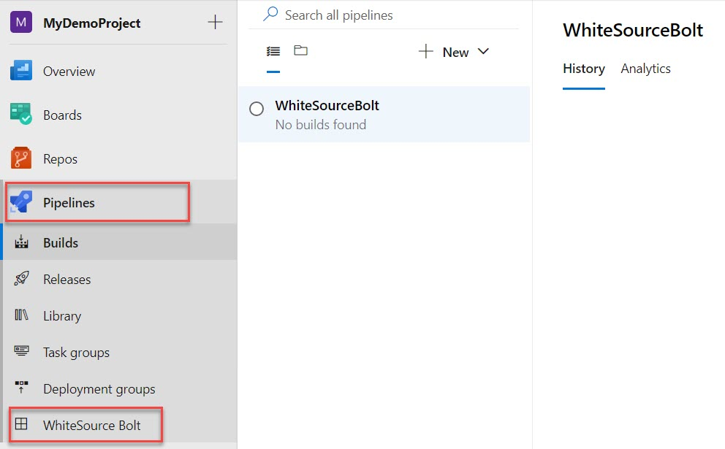

Step 8: Register as below:

Work Email: Enter email id

Company Name: Self Employed

Country: Choose from list

Click on Get Started button.

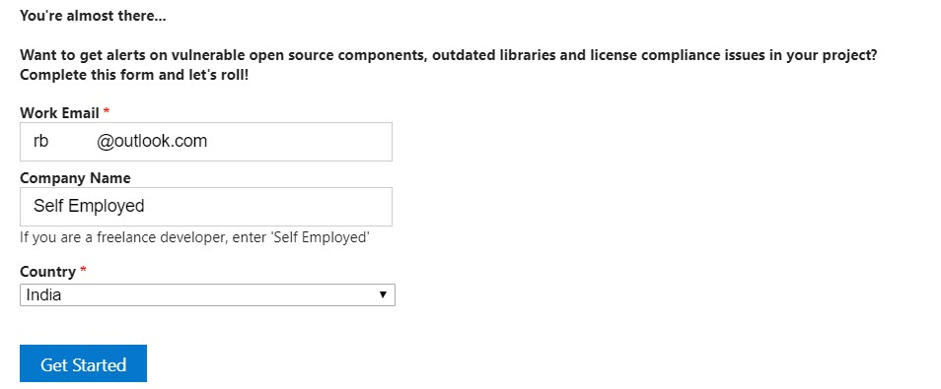

Wait for few seconds to register.

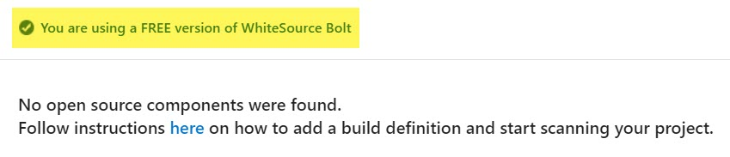

Step 9: Builds -> WhiteSpurceBolt -> Edit

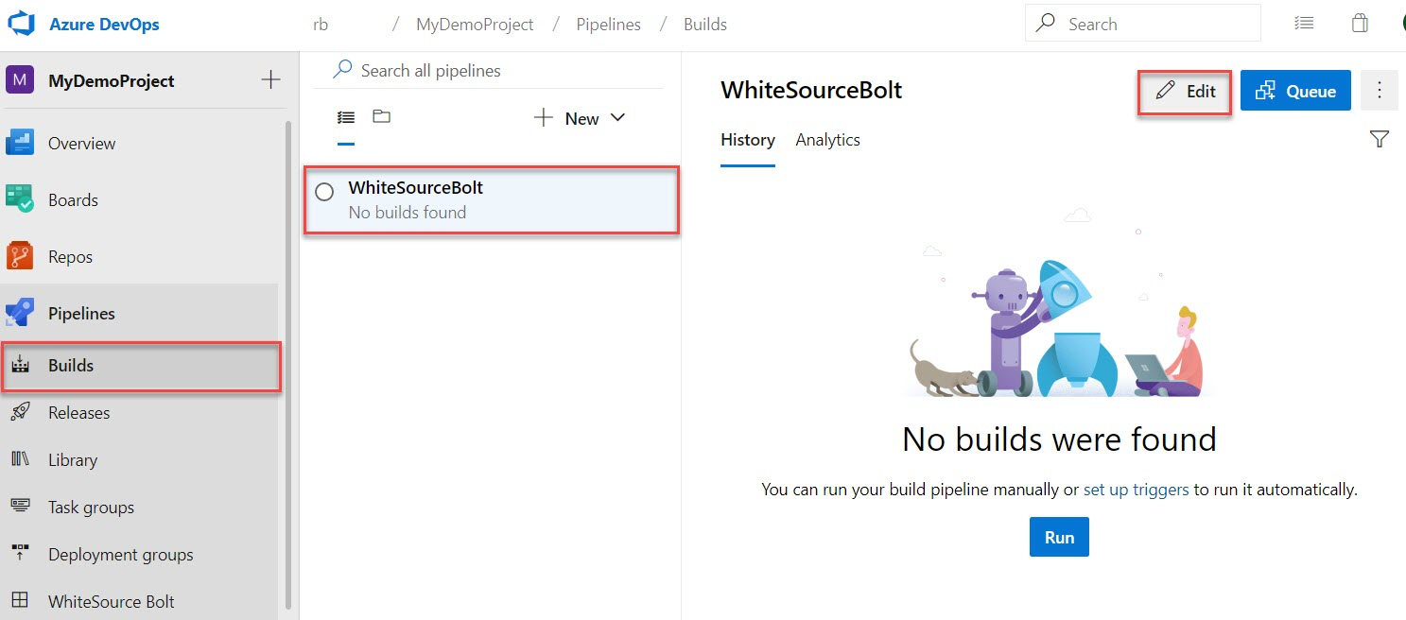

Step 10: Verify Pipeline

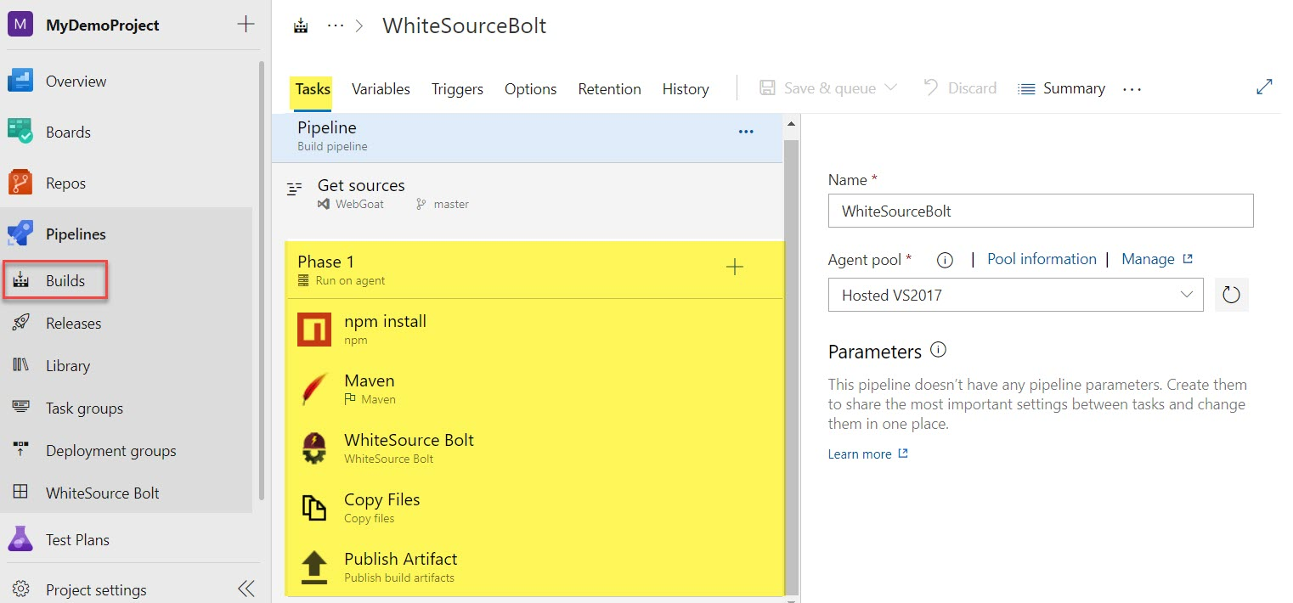

Step 11: Click on Queue button.



Step 12: Click on Run

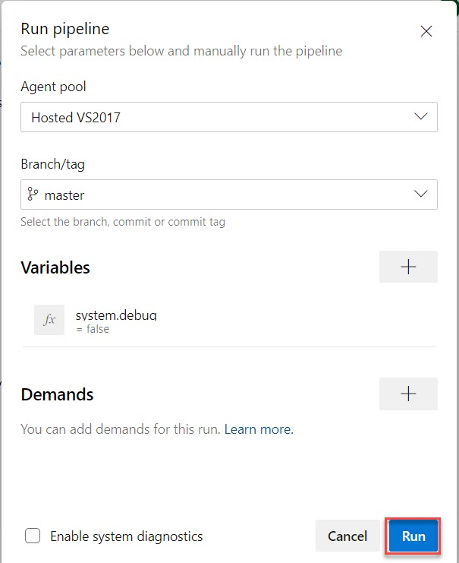

Step 13: Check Build Result

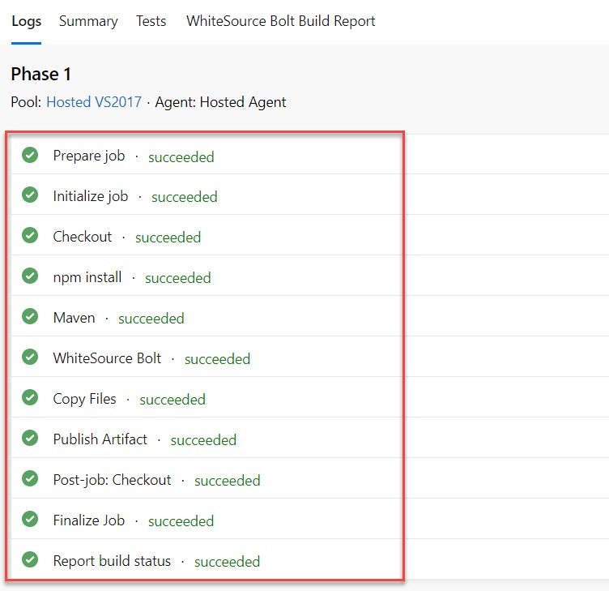

Step 14: Click on WhiteSource Bolt in Pipeline option

